Windows Azure Samples

How to use the Umbraco Azure Accelerator

Version: 1.0

Last updated: 5/2/2011

* 1. 

Content

Overview 3

How does it work? 3

Get Started 4

Create a Windows Azure Storage Account 4

Start the Setup Script 5

Deploy Accelerator to Windows Azure 6

Configure Umbraco with the Setup Script 9

Creating the SQL Azure Server (optional) 13

Manually Uploading the Umbraco Site to Blob Storage (optional) 16

Next Steps 17

Scale out your Umbraco application 17

Run multiple Umbraco sites within the same Windows Azure Instances 18

Use the Windows Azure AppFabric Caching service for Session State 18

Integrate the Access Control Service into Umbraco 20

Create a DNS entry for your Umbraco site 20

Overview

* 1. The Windows Azure Accelerator for Umbraco is designed to enable Umbraco applications to be easily deployed into the Windows Azure. By running in Windows Azure, Umbraco applications can benefit from the automated service management, reduced administration, high availability, and scalability provided by the Windows Azure Platform. For more information about the benefits of Windows Azure, please visit the [Windows Azure web site](http://www.microsoft.com/windowsazure/compute/default.aspx).
  2. The accelerator has been designed to enable you to rapidly deploy Umbraco applications and updates to your application without redeploying a full Windows Azure Service Package.

## How does it work?

* 1. The accelerator is a simple application which synchronizes the instance of Umbraco in the Hosted Service with those stored in Blob Storage. This synchronization occurs both ways, that way, any change done on an instance is replicated to all the other.
  2. If a new instance of Umbraco is detected in blob storage, then a new site is created and configured in the Hosted Service IIS, leveraging the Full IIS feature introduced with Windows Azure SDK & Tools 1.3.
  3. 
  4. Figure
  5. Windows Azure Accelerator for Umbraco Deployment & Usage

### Prerequisites

* 1. For running the setup scripts and generating the deployment package you will need the following pre-requisites:
  + [Visual Studio 2010 and .NET 4](http://msdn.microsoft.com/vstudio/products/)
  + [Windows Azure SDK and Tools for Visual Studio (March 2011) version 1.4](http://go.microsoft.com/fwlink/?LinkID=128752)
  + [SQL Express 2008 R2](http://www.microsoft.com/express/sql/download/)

Get Started

This page provides setup instructions and a guide on how to use the Windows Azure Accelerator for Umbraco bits to deploy an instance of Umbraco to Windows Azure.

* 1. Create a Windows Azure Storage Account
  2. Start the Setup Script
  3. Deploy Accelerator to Windows Azure
  4. Configure Umbraco with the Setup Script
  5. Creating the SQL Azure Server (optional)
  6. Manually Uploading the Umbraco Site to Blob Storage (optional)

## Create a Windows Azure Storage Account

* 1. This sample requires a Windows Azure Storage account for leveraging Blob Storage. To create an account, proceed as shown in the following steps.
  2. Log on to the [Windows Azure Platform](http://windows.azure.com) portal, and click **New Storage Account** on the ribbon.
  3. In the **Create a New Storage Account** dialog, pick your subscription from the drop down list labeled **Choose a subscription**.
  4. Enter a valid name for your storage account in the textbox labeled **Enter a URL.**
  5. Finally, select a region were the Storage Account will be hosted and click **Create** to register your new storage account. Wait until the account provisioning process completes and updates the **Storage Accounts** tree view.
     1. 
     2. Figure
     3. Creating a new Storage Account
  6. Select the newly created storage account and, in the **Properties** pane, click the **View** button next to **Primary access key**. In the **View Storage Access Keys** dialog, click **Copy to Clipboard** next to the **Primary Access Key**. You will use this value as well as the storage account name later on to configure the application.
     1. 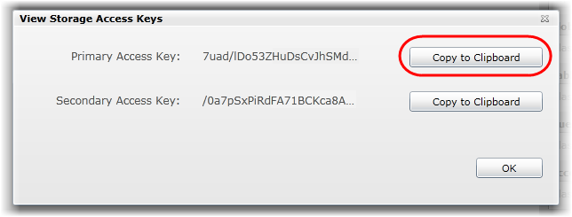
     2. Figure
     3. Retrieving the storage access keys

## Start the Setup Script

* 1. This sample provides a command line setup that will guide you through the process of configuring the Azure Accelerator and the Umbraco site.
  2. Run the **Setup.cmd** script located in the root directory were you extracted the sample.
  3. First, you will be asked to provide the Storage Account name and key that will be used to upload the files to blob storage and to configure the **DataConnectionString** in the accelerator instance.
     1. 
     2. Figure
     3. Providing Storage Account Name and Key
  4. Next, you will be prompted to manually deploy the Accelerator to Windows Azure. You can follow the steps described below to do so.

## Deploy Accelerator to Windows Azure

* 1. The first step for Deploying the Accelerator to Windows Azure is generating the Deployment Package.
  2. Open the **Umbraco** solution located inside the **code** folder were you installed this sample.
  3. In the Solution Explorer, right click on the **UmbracoAccelerator** Cloud Project and select **Publish.**
  4. Select **Create Service Package Only** and click **OK**. Once your publication succeeds, an Explorer window will pop up containing the Deployment Package and the ServiceConfiguration.
     1. **Note:** Windows Azure provides the ability to specify an instance size in the Service Definition file (csdef) which is deployed as part of the Windows Azure Service Package. The instance size specifies the amount of memory, CPU, local storage, and network performance for the underlying Virtual Machine image. By default, the accelerator is configured to use two extra small instances. For more information about instance sizes, please review the MSDN documentation on this subject located [here](http://msdn.microsoft.com/en-us/library/ee814754.aspx). Each instance size also has different pricing. You can find more information about pricing [here](http://www.microsoft.com/windowsazure/pricing/).
  5. Next, you’ll need to create a Windows Azure Hosted Service:
  6. Log on to the [Windows Azure Platform](http://windows.azure.com) portal, and click on **New Hosted Service** on the ribbon.
  7. In the **Create a new Hosted Service** dialog, select the subscription where you wish to create the service from the drop down list labeled **Choose a subscription**.
  8. Enter a service name in the textbox labeled **Enter a name for your service** and choose its URL by entering a prefix in the textbox labeled **Enter a URL prefix for your service**.
  9. Select the same region chosen for the storage account.
  10. For the Deployment Options, chose **Deploy to Production**, enter a label to identify the deployment and browse locally for the Package and Service Configuration you’ve generated on previously.
      1. 
      2. Figure
      3. Creating the Windows Azure Hosted Service
  11. Finally, you’ll need to upload the remote desktop certificate. To do this:
      1. Click on **Add Certificate** and in the Upload Certificates dialog, click **Browse**.
      2. Browse to the folder were you installed the package and under **assets** you will find the Remote Desktop certificate named **Remote.pfx**.
      3. Enter **q3&d3new7@0** as the certificate password and click **OK**
         1. **Note:** The remote desktop user and password are already configured in the deployment package. It is recommended you change this user and password through the management site
         2. **user**: admin / **password**: q3&d3new7@0
         3. 
         4. Figure
         5. Creating the Windows Azure Hosted Service
  12. Click **OK** to create the Service.
  13. Notice that the package begins to upload and that the portal shows the status of the deployment to indicate its progress. This process will take anywhere from 5-15 minutes.

## Configure Umbraco with the Setup Script

* 1. Go back to the command line window and press any key to proceed with the configuration process.
  2. You will be asked to provide the SQL Azure server, database name and credentials to setup Umbraco’s database.
     1. **Note:** if you don’t have a SQL Azure Server you can follow the steps described below
     2. 
     3. Figure
     4. Migrating Umbraco Database to SQL Azure step
  3. Once the setup script completes creating the database and its schema, you will be prompted if you want to setup a clean database. Choose **Y** if you don’t have a local version of Umbraco already configured and you are performing a clean install.
     1. **Note:** If you already have an instance of Umbraco running locally you'll need to migrate the SQL Server database to SQL Azure. To do this, you can use the SQL Azure Migration Wizard (<http://sqlazuremw.codeplex.com/>) and follow the instructions to migrate your database.
     2. 
     3. Figure
     4. Creating a clean Umbraco Database step
  4. Next, you will be asked to download and extract Umbraco from codeplex (<http://umbraco.codeplex.com>). Once you finish the step, go back to the command line window and press any key to continue.
     1. **Note:** The latest version of Umbraco tested using the Windows Azure Accelerator for Umbraco was 4.7.
  5. After the download completes, extract the downloaded package to a known location. Inside the build folder you’ll find the Umbraco binaries.
  6. To configure Umbraco you will need to provide the path to where the binaries were extracted.
     1. **Note:** You will need to provide the full path (including the trailing slash) were the Umbraco binaries are located.
     2. 
     3. Figure
     4. Providing the path to Umbraco
  7. Next, you will be prompted to provide the Session State database name. The setup script will use the same server you provided previously for creating this database.
     1. 
     2. Figure
     3. Session State Database Step
     4. **Note:** The setup script will automatically generate a Machine Key and configure it in Umbraco’s web.config file.
  8. Finally, the setup script will start a tool which will allow you to upload the site to Blob Storage. To do this, you will need to provide with the site name, which will be used as host header in IIS.
     1. **Note:** If you want to upload the site manually, you can follow the steps described below. Or run the tool manually running the provided script “**UploadUmbracoSite.cmd**” located inside the **setup** folder were you installed this sample.
     2. 
     3. Figure
     4. Uploading Umbraco to Blob Storage Step

## Creating the SQL Azure Server (optional)

* 1. Log on to the [Windows Azure Platform](http://windows.azure.com) portal, and click **New Database Server** on the ribbon.
  2. To create a server, select your subscription on the left pane. Click on **Create** on the **Server** ribbon.
  3. Select a region from the **Region** drop down list, and then click **Next**. The location determines which datacenter the database will reside in.
  4. Enter an administrator account name and password and click **Next**.
     1. **Note:** An administrator account is a master account used to manage the new server. You should avoid using this account in connection strings where the username and password may be exposed.
     2. The password policy requires that the password follows certain rules.
     3. 
  5. Click **Finish** to create the new server. You will configure firewall rules later on this exercise.
  6. Finally, the new server information, including **Fully Qualified Server Name**, is shown.
     1. 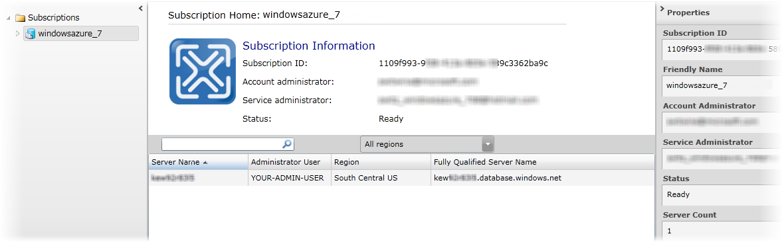
     2. Figure
     3. SQL Azure projects list
     4. **Note:** The fully qualified domain name of the server uses the following format:
     5. *<ServerName>.database.windows.net*
     6. where *<ServerName>* identifies the server, for example, *a9ixtp7pux.database.windows.net*.
  7. Expand the subscription node located on the left pane, and then click on the server name you have created. The **Server** **Information** page allows you to perform basic administration of the database server.
     1. 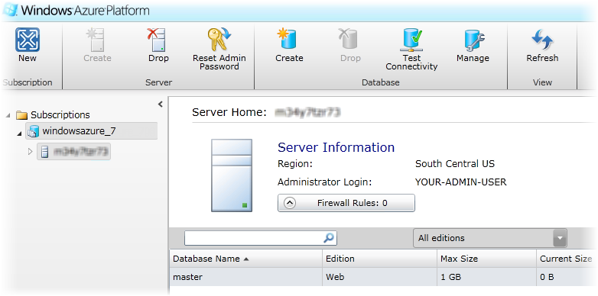
     2. Figure
     3. SQL Azure server information page
  8. The **Firewall Rules** allows you to specify a list of IP addresses that can access your SQL Azure Server. The firewall will deny all connections by default, so **be sure to configure your allow list** so that existing clients can connect to the server.
     1. 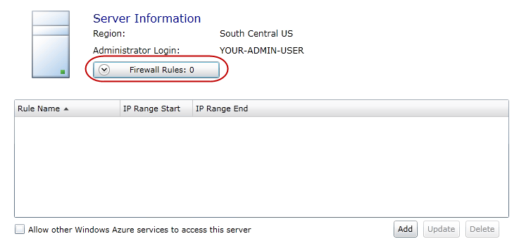
     2. Figure
     3. Configuring the firewall settings for SQL Azure
     4. **Note:** Changes to your firewall settings can take some time to become effective.

## Manually Uploading the Umbraco Site to Blob Storage (optional)

* 1. The final step is to copy your Umbraco site into the storage account you created previously.
  2. You'll need a tool to copy data in and out of Windows Azure blob storage. One free tool that is available for accessing Windows Azure blob storage is [ClumsyLeaf CloudXplorer](http://clumsyleaf.com/products/cloudxplorer).
  3. Configure the tool to work with the storage account you created previously
  4. Create a container in your blob storage account called "sites".
  5. Under that container, create a directory named after the host name of your website. E.g., if your website is www.example.org, create a directory called "www.example.org".
  6. Copy your entire Umbraco website into that directory. Depending on the size of the content, this may take 5-10 minutes or more.
     1. 
     2. Figure
     3. Uploading Umbraco with CloudXPlorer
     4. **Note:** If your Umbraco site has empty folders you’ll need to create them manually in blob storage since CloudXPlorer does not copy empty directories.
     5. **Note:** Before you can view the site in Windows Azure, you'll have to configure your domain (generally via a domain registrar, like GoDaddy) to point to Windows Azure. Create a CNAME record that maps the host (e.g. www.example.org) to the Windows Azure application (e.g. example.cloudapp.net). Once that's done, you should be able to browse to the domain and see your site.
     6. (Optional) If you want to test the configuration before you update your domain settings, you can edit the %windir%\system32\drivers\etc\hosts file on your computer to point the domain at your Windows Azure application. To do that, run ping example.cloudapp.net from a command prompt and copy the IP address that appears. Then add a line to the hosts file that says "123.123.123.123 www.example.org" (replacing 123.123.123.123 with the IP address you saw)

Next Steps

* 1. Once you have the Windows Azure Accelerator for Umbraco up and running, there are several ways you can extend your Umbraco site to take advantage of the Windows Azure Platform. A few of these approaches include:
  + Scale out your Umbraco application
  + Run multiple Umbraco sites within the same Windows Azure Instances
  + Use the Windows Azure AppFabric Caching service for Session State
  + Integrate the Access Control Service into Umbraco
  + Create a DNS entry for your Umbraco site

## Scale out your Umbraco application

* 1. Through the Windows Azure Platform Management Portal (<https://windows.azure.com/>) you can easily add more Windows Azure instances to the Windows Azure Accelerator for Umbraco.
  2. Log on to the [Windows Azure Platform](http://windows.azure.com) portal, and click **Hosted Services, Storage Accounts & CD** on the lower part of the left pane.
  3. In the upper part of the left pane, choose **Hosted Services**.
  4. Select your Accelerator deployment on the middle pane and click **Configure**, on the ribbon.
  5. In the Configure Deployment dialog, choose **Edit current configuration**, and change the Instances count value in the configuration XML.
     1. 
     2. Figure
     3. Configure Deployment Dialog
  6. The Windows Azure Accelerator for Umbraco will automatically replicate the Umbraco sites on each new instance, allowing your Umbraco instance to scale out.
  7. **Note:** Alternatively you can change the number of instances programmatically using the service management API (<http://msdn.microsoft.com/en-us/library/ee460799.aspx>)

## Run multiple Umbraco sites within the same Windows Azure Instances

* 1. The Windows Azure Accelerator for Umbraco supports deploying multiple instances of Umbraco using the same accelerator, to do so you’ll need to follow the setup script again, using different Umbraco and Session State Databases.
  2. Additionally, when uploading the Umbraco site, you’ll need to provide a different host header and create the CNAME record in your domain to perform the appropriate mapping.
  3. **Note:** Performance might be affected if you run too many Umbraco websites with the same accelerator. If you notice performance degradation you try scaling up, incrementing the VM Size, or scaling out, incrementing the amount of instances for the Accelerator.

## Use the Windows Azure AppFabric Caching service for Session State

* 1. Instead of using SQL Azure as session state provider, you could configure the Windows Azure AppFabric Caching services for it. To do so you need to follow these steps:
  2. Log on to the [Windows Azure AppFabric](http://portal.appfabriclabs.com/) labs portal and select **Service Bus, Access Control & Caching.**
  3. Create a New Namespace and, once the activation completes, select **View Client Configuration** from the ribbon.
  4. Open your web site’s web.config file and add the **dataCacheClient** section from the **Client Configuration** dialog, inside the **configSections** node.
     1. XML

<section name="dataCacheClient" type="Microsoft.ApplicationServer.Caching.DataCacheClientSection, Microsoft.ApplicationServer.Caching.Core" allowLocation="true" allowDefinition="Everywhere"/>

* 1. Add the **dataCacheClient** configuration from the **Client Configuration** dialog after the closing **configSections** XML tag.
     1. XML
     2. <dataCacheClient deployment="Simple">
     3. <hosts>
     4. <host name="umbracoAccelerator.cache.appfabriclabs.com" cachePort="22233" />
     5. </hosts>
     6. <securityProperties mode="Message">

<messageSecurity authorizationInfo="..."></messageSecurity>

* + 1. </securityProperties>
    2. </dataCacheClient>
  1. Next, replace the **sessionState** configuration with the one shown in the **Client Configuration** dialog.
     1. XML
     2. <sessionState mode="Custom" customProvider="AppFabricCacheSessionStoreProvider">
     3. <providers>
     4. <add name="AppFabricCacheSessionStoreProvider" type="Microsoft.Web.DistributedCache.DistributedCacheSessionStateStoreProvider, Microsoft.Web.DistributedCache" cacheName="default" useBlobMode="false" />
     5. </providers>
     6. </sessionState>
  2. Finally, you will need to copy the caching assemblies included in the [Windows Azure AppFabric SDK 2.0](http://www.microsoft.com/downloads/en/details.aspx?FamilyID=d89640fc-c552-446e-aead-b1e0d940f31b) into Umbraco’s bin folder.
     1. 
     2. Figure
     3. Windows Azure AppFabric SDK 2.0 Caching Assemblies

## Integrate the Access Control Service into Umbraco

* 1. The Access Control Service Extensions for Umbraco augment your web site with powerful identity and access management capabilities:
  + Authenticate users from social identity providers such as Facebook, Windows Live ID, Google and Yahoo.
  + Manage those users and access policies though the familiar Umbraco management UI, without the hassle of maintaining passwords for them!
  + Make your web site available to business federated partners from Active Directory or any other identity provider with federation capabilities. Apply fine-grained access policies mapping claims to your existing Member Groups.
  + Handle user invitations via a powerful email invitation & verification system.
  1. All those capabilities are implemented by integrating with the Windows Azure AppFabric Access Control Service.
  2. You can download the Access Control Service Extensions for Umbraco from <http://umbracoacsextensions.codeplex.com>

## Create a DNS entry for your Umbraco site

* 1. To browse the site deployed using the Azure Accelerator for Umbraco you will need to configure your domain to point to Windows Azure, and create a CNAME record that maps the host (e.g. www.contoso.com) to the Windows Azure application (e.g. contoso.cloudapp.net).
  2. For detailed instructions on how to configure this you can read Steve Marx’s blog post [here](http://blog.smarx.com/posts/custom-domain-names-in-windows-azure).